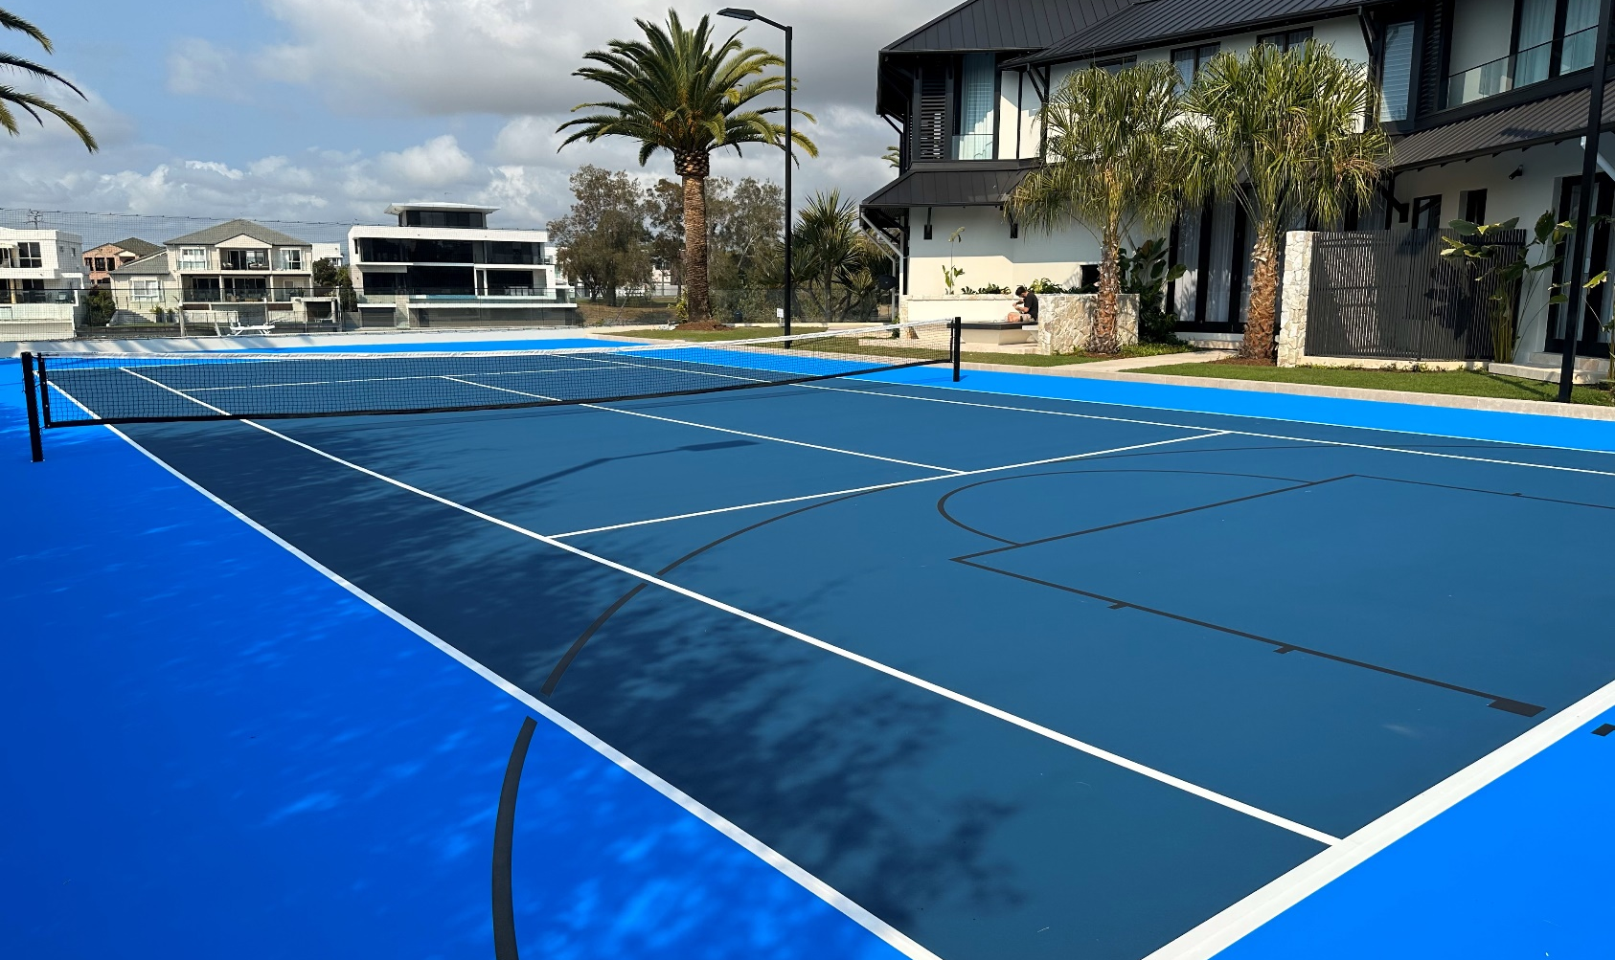

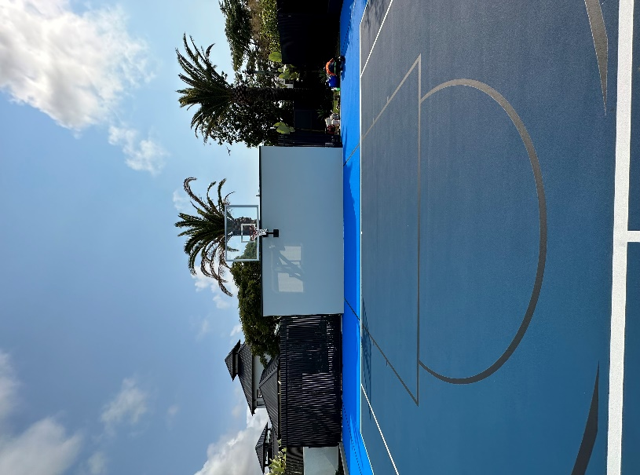
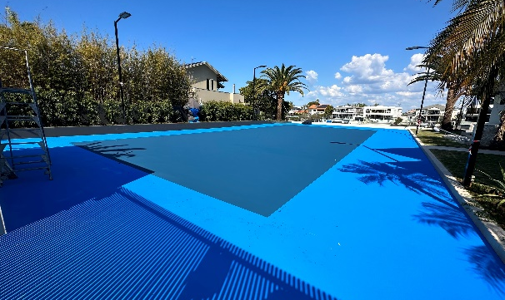
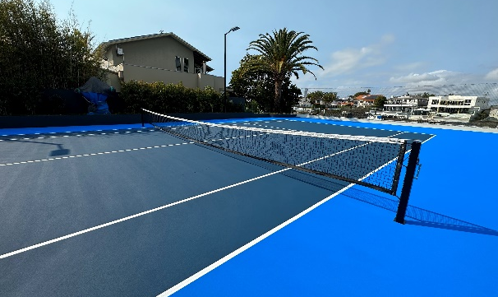
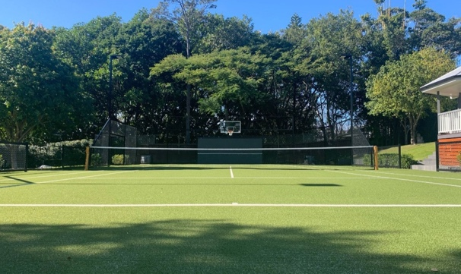  CLIENT: | Clamroc Constructions - La Scala Project
DURATION: | 3 Weeks
SURFACE: | Laykold Acrylic Hard Court
Premier Sports and Leisure was approached by Clamroc Constructions with a specific request for a private sport court that would meet their clients’ unique needs. The clients wanted a facility that would allow them to play their favourite sports such as tennis and basketball from the comfort of their own home. Additionally, they wanted a design that would complement the current house and landscaping renovations underway.
Premier collaborated with Clamroc Constructions, a renowned construction company to bring the clients vision to life. This included providing a custom fabricated wall-mounted basketball system, court lighting, retractable court fencing, and a two-toned blue court surface.
This project showcases the expertise and dedication of both companies in delivering a high-quality and custom facility. The clients were overjoyed with the end result, and the sports court continues to be a source of enjoyment for them and their guests.

